Here it is long before the end of the century and already astounding progress has been made.

# The end of poverty: What globalization did that aid could not

[Peter Goodspeed](http://news.nationalpost.com/author/pgoodspeednp/" \o "View all posts by Peter Goodspeed)  May 28, 2011 – 8:00 AM ET | **Last Updated: May 27, 2011 9:21 PM ET**

In 2005, the G8 Summit in Gleneagles, Scotland, was hijacked by the politically fashionable.

More than three billion people worldwide witnessed Live 8, a multi-city music marathon dedicated to Making Poverty History; 26 million people signed online petitions; 250,000 protesters marched through the streets of Edinburgh and dissidents around the world wrapped landmarks like London’s St. Paul’s Cathedral and Australia’s Harbour Bridge in Sydney in white banners as part of a global movement to press for international debt relief, trade reform and increases in foreign aid.

After the music ended and the pious tributes and promises of political action faded, people went back to their daily lives.

Still, something did happen.

Most people haven’t noticed yet, but according to a recent study by the Brookings Institution in Washington, we have just lived through the most dramatic decrease in global poverty in history.

And the transformation has almost nothing to do with debt relief or higher aid flows.

According to the Brookings report, Poverty in Numbers: The Changing State of Global Poverty from 2005 to 2015, we are living in a period of rapid global poverty reduction that is driven by high, sustained economic growth across the developing world.

Nearly half a billion people escaped living at or below the poverty threshold of US$1.25-a-day between 2005 and 2010, say the study’s authors Laurence Chandy and Geoffrey Gertz.

“Never before in history have so many people been lifted out of poverty in such a short period,” they said.

The change, driven by the highest levels of sustained economic growth recorded in the developing world, has been so dramatic that the United Nations Millennium Development Goal to halve the rate of global poverty between 1990 and 2015 was probably already achieved by 2008 — seven years ahead of schedule, the Brooking report says.

[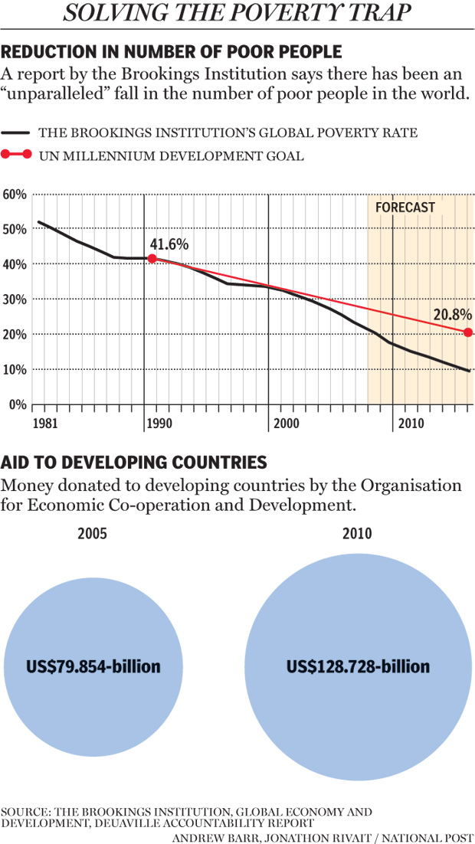](http://nationalpostnews.files.wordpress.com/2011/05/fo0528-poverty-eps.jpg)

“A lot has changed in the past six years,” the study says. “The economies of the developing world have expanded 50% in real terms, despite the Great Recession. Moreover, growth has been particularly high in countries with large numbers of poor people. India and China, of course, but also Bangladesh, Tanzania, Ethiopia, Vietnam, Uganda, Mozambique and Uzbekistan — nine countries that were collectively home to nearly two-thirds of the world’s poor in 2005 — are all experiencing phenomenal economic advances.”

Over the next four years, the report predicts, another 300 million people should escape poverty.

“At that point, the 1990 poverty rate will have been halved and then halved again,” the study says.

“Today growth is being driven by a number of big countries which are home to large poor populations,” said Mr. Chandry. “Between 2005 and 2015, India (current population of 1.233 billion) Bangladesh (169 million), Vietnam (89 million) and Ethiopia (87 million) are each expected to grow by at least 6.3% per year. In the process, each is likely to see a quarter of its population lifted out of poverty.”

That economic growth generates a momentum all its own.

This week a UN report on the world’s economic prospects for 2011 predicted large economies in developing countries such as China, Brazil and India, will continue to lead the global recovery, amid weaker performances in relatively richer nations like Canada, the United States and Britain, which are all plagued by concerns over huge public debts.

India and China have boomed since they abandoned central planning and adopted globalized, market-driven economies powered by young, well-educated, low-wage workforces and underwent rapid industrialization and urbanization.

“In 2040, the Chinese economy will reach US$123-trillion, or nearly three times the economic output of the entire globe in 2000,” predicted economist Robert Fogel, director of the Center for Population Economics at the University of Chicago.

“China’s per-capita income will hit US$85,000, more than double the forecast for the European Union, and also much higher than that of India and Japan,” he said. “In other words, the average Chinese megacity dweller will be living twice as well as the average Frenchman.”

In light of such economic development, said Mr. Chandry, “The Gleneagles Summit and the hoopla surrounding it appear both antiquated and naïve.”

Despite significant increases in foreign aid, anti-poverty activists accuse G8 countries of falling US$19-billion short of their 2005 promises to increase foreign aid by US$50-billion.

The G8 has also shifted its focus away from debt relief and foreign aid to trying to salvage failed and failing states and concentrating on issues like climate change.

Nevertheless, “the development landscape has shifted immeasurably, with some emerging countries becoming key drivers of the global economy,” Mr. Chandry said.

Income poverty in China “could all but disappear by 2015,” he said, predicting that by 2015 only 0.3% of the Chinese population will be living on less than $1.25-a-day.

“This would mean that, between 2010 and 2015, 50.1 million Chinese people would lift themselves out of income poverty, potentially bringing the total reduction in Chinese citizens living on $1.25-a-day since 2000 to 203.3 million,” the Brookings report says.

That’s second only to India, where rapid economic growth is expected to lift 367 million people out of poverty by 2015.

In India, however, up to 7% of the population will still live on $1.25-a-day or less.

While the landscape of global poverty is changing, it is also becoming much more complex. The arrival of emerging markets and a shift of economic power away from the West have the potential to change everything from global investment opportunities, to the balance of military power and the way international institutions function.

For one thing, the face of world poverty is increasingly going to be African.

In 2005, China and India accounted for more than half the world’s poor, but now they are responsible for three-quarters of the global reduction in poverty and Asia’s share of the world’s poor is shrinking from two-thirds to just one-third.

As a result, Africa’s share of the world’s poor is expected to more than double to 60% of the total.

Since 1999, India has been home to more poor people than any other country, but by 2015, that burden will pass to Nigeria.

“Poverty will increasingly be seen as an African problem, despite the clear progress the continent is now making,” says the Brookings report.

The Brookings economists estimate poverty in Africa “dropped below the 50% mark for the first time” in 2008 and predict that by 2015 it will fall below 40%, a feat China did not achieve until the mid-1990s.

Still, the rapidly changing landscape of global poverty is going to require a matching change in strategies to fight it, say Mr. Chandry and Mr. Gertz.

In addition to major regional changes, the world’s poor no longer live in poor countries. They are increasingly found in middle-income countries and in fragile states.

That makes it more difficult to do something for them.

For one thing, the need for financial assistance is less compelling, since middle-income countries do not face the same financial constraints, such as access to capital markets, as low-income countries.

Fragile states also present more political than economic problems for aid donors, because there is little consensus on what interventions are most successful in unstable environments.

Aid donors also don’t have as much leverage on middle-income and fragile states as they do in stable, low-income states.

In the long run, aid donors may have to think about moving away from the idea of helping poor countries and refocus their attention on helping poor individuals, the Brookings study says.

It even suggests a global welfare system might someday be possible.

“Our results suggest that providing every person in the world with a minimum income of $1.25-a-day — in other words guaranteeing the right not to live in absolute poverty — is rapidly becoming feasible,” the study says.

“In 2005, supplementing the income of each poor person in the world to bring their daily income up to $1.25 would have cost US$96-billion, or 80% of the total volume of foreign aid disbursed that year. In 2010, with poverty less widespread and larger global aid volumes, the cost of such a global safety net would be just $66-billion, or slightly more than half of all official aid.”

Still, it is global economic growth, not aid, that seems to have the biggest impact on poverty reduction.

“There is growing recognition that our understanding of what causes growth, and how we might ‘make poverty history,’ remains incomplete,” Mr. Chandry said.

“Nevertheless, the rate at which the developing world is now pulling people above the $1.25 threshold is tantalizing,” his report says. “The ‘dream of a world free of poverty,’ the oft-ridiculed motto emblazoned at the entrance of the World Bank, is, year by year, coming closer to reality.”

National Post  
[pgoodspeed@nationalpost.com](mailto:pgoodspeed@nationalpost.com)

[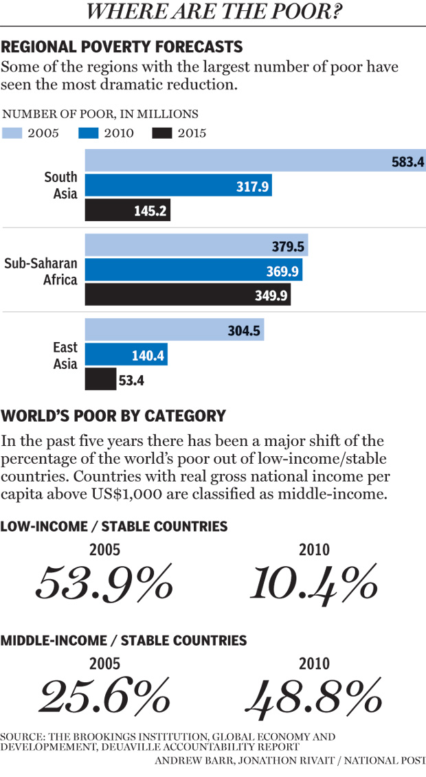](http://nationalpostnews.files.wordpress.com/2011/05/poverty.jpg)

Posted in: [Features](http://news.nationalpost.com/category/features-2/), [News](http://news.nationalpost.com/category/news-2/), [World](http://news.nationalpost.com/category/news-2/world/)  Tags: [Africa](http://news.nationalpost.com/tag/africa/), [Bangladesh](http://news.nationalpost.com/tag/bangladesh/), [Brazil](http://news.nationalpost.com/tag/brazil/), [Brookings Insitution](http://news.nationalpost.com/tag/brookings-insitution/), [China](http://news.nationalpost.com/tag/china/), [Economic Growth](http://news.nationalpost.com/tag/economic-growth/), [Edinburgh](http://news.nationalpost.com/tag/edinburgh/), [Ethiopia](http://news.nationalpost.com/tag/ethiopia/), [Geoffrey Gertz](http://news.nationalpost.com/tag/geoffrey-gertz/), [Gleneagles](http://news.nationalpost.com/tag/gleneagles/), [India](http://news.nationalpost.com/tag/india/), [Laurence Chandy](http://news.nationalpost.com/tag/laurence-chandy/), [Live 8](http://news.nationalpost.com/tag/live-8/), [Make Poverty History](http://news.nationalpost.com/tag/make-poverty-history/), [Mozambique](http://news.nationalpost.com/tag/mozambique/), [Poverty](http://news.nationalpost.com/tag/poverty/), [Poverty in Numbers: The Changing State of Global Poverty from 2005 to 2015](http://news.nationalpost.com/tag/poverty-in-numbers-the-changing-state-of-global-poverty-from-2005-to-2015/), [Scotland](http://news.nationalpost.com/tag/scotland/), [Tanzania](http://news.nationalpost.com/tag/tanzania/), [U.K.](http://news.nationalpost.com/tag/u-k/), [uganda](http://news.nationalpost.com/tag/uganda/), [United Kingdom](http://news.nationalpost.com/tag/united-kingdom/), [United Nations Millennium Development Goal](http://news.nationalpost.com/tag/united-nations-millennium-development-goal/), [Uzbekistan](http://news.nationalpost.com/tag/uzbekistan/), [Vietnam](http://news.nationalpost.com/tag/vietnam/)

#### More from [Peter Goodspeed](http://news.nationalpost.com/author/pgoodspeednp/)